Willow Westbrook
Professor Mee
ISOM-230
9/20/23
Assignment 1: Excel Pivot Tables

Flops:
The product that sold the least number of units was Fixed Gear Bikes (FXGR1000).
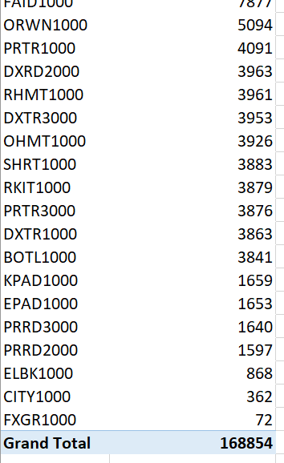
Top Seller:
The product category that provided the most amount of revenue in 2011 was Touring Bikes (TOU).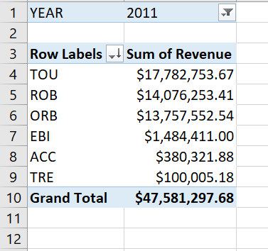
Sales by Product Category:
The percentage that off-road bikes contributed to the overall bike sales quantity was 22.9%
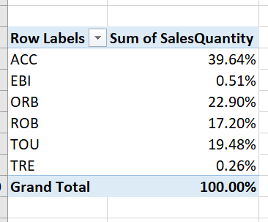
The three cities where the percentage was above the average were Muchen, Boston, and Hamburg.
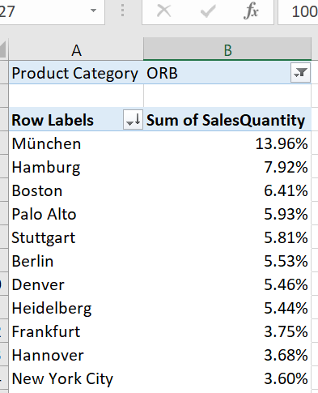
Seasonal Behavior:
The product that is an exception to this rule is a bicycle pump, who had the largest sales quantity during that period of fall through winter.
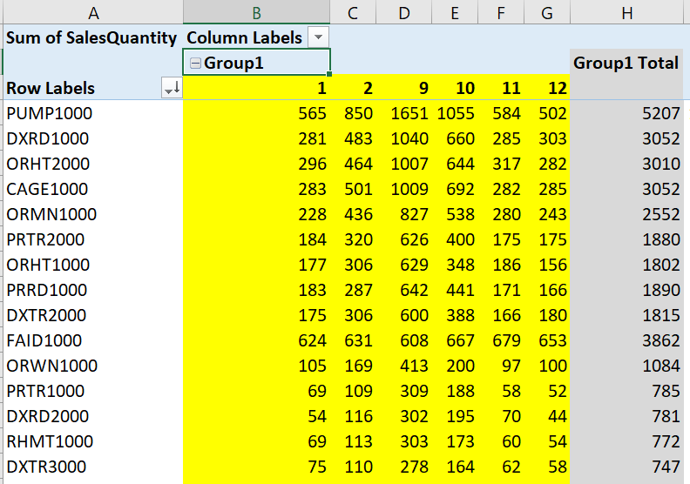
(I formed a group in the table containing the fall and winter months to see what product had the best amount of sales quantity during this period.)

